

COLLEGE PAYROLL ACCOUNTING
(130)

NATIONAL – 2020

Multiple Choice & Short Answer Section:

Multiple Choice (15 @ 2 points each) (30 points)

Short Answers Questions (40 @ 2 points each) (80 points)

Production Portion:

Problem 1: Percentage Method Withholding (20 points)
Problem 2: Tax Deposit (22 points)
Problem 3: Form W-3 (44 points)
Problem 4: Form 941 (38 points)

TOTAL POINTS (234 points)

Graders: Please double check and verify
all scores and answer keys!

Property of Business Professionals of America.
May be reproduced only for use in the Business Professionals of America
Workplace Skills Assessment Program competition.

General Instructions

You have been hired as a Financial Assistant and will be keeping the accounting records for Professional Business Associates, located at 5454 Cleveland Avenue, Columbus, Ohio 43231. Professional Business Associates provides accounting and other financial services for clients. You will complete jobs for Professional Business Associates’ own accounting records, as well as for clients.

You will have 90 minutes to complete your work. The test is divided into two parts. The multiple choice and short answer questions should be completed first, and then the accounting problems may be completed in any order.

Your name and/or school name should NOT appear on any work you submit for grading. Write your contestant number in the provided space. Staple all pages in order before you turn in your test.

Assumptions to make when taking this assessment:

- Calculate all calculations to four (4) decimals, then round to the nearest cent.
- 2019 Payroll Tax Rules Apply
- Social Security (OASDI): 6.2% on the first $132,900
- Medicare (HI): 1.45%
- FUTA: .6% on first $7,000 of employee wages
- SUTA: Information is in each question

Multiple Choice: (30 points, 2 each)

- B
- D
- D
- A
- D
- B
- C
- B
- D
- C
- D
- A
- B
- A
- C

Short Answer Questions: (80 points, 2 each)

Employee | Cumulative Earnings Prior Pay Periods | Current Pay Period Earnings | FUTA/SUTA Taxable Amount | FUTA Tax Liab | SUTA Tax Liab | FICA Tax Liab
Reagan | 7,023.00 | 985.00 | 0
Carter | 6,511.25 | 1,925.25 | 488.75
Kennedy | 1,580.00 | 366.00 | 366.00
Clinton | 2,989.00 | 677.00 | 677.00
Truman | 9,940.63 | 1,358.47 | 0
Ford | 4,418.00 | 2,125.00 | 2125.00
Wilson | 6,502.99 | 895.00 | 497.01
Totals | 38,964.87 | 8,331.72 | 4,153.76 | 24.92 | 109.24 | 637.38

Employee | Annual Salary | Weekly | Bi-Weekly | Semi-Monthly | Monthly
Abigail | 26,580 | 511.15 | 1022.31 | 1107.50 | $2,215
Dolley | 43,140 | 829.62 | 1,659.23 | 1,797.50 | $3,595
Elizabeth | 54,000 | 1,038.46 | 2,076.92 | 2,250.00 | $4,500
Louisa | 51,528 | 990.92 | 1,981.85 | 2,147.00 | $4,294
Emily | 40,512 | 779.08 | 1,558.15 | 1,688.00 | $3,376

- $1,857.27

- $948.57,
$25.64
$948.57

- (40 x 12.58 =503.20) (4 x 18.87=75.48) 578.68 x .062=35.88

- Hourly wage from tips $2.19
Hourly wage employer pays her $5.06

Problems

- (20 points, 5 points each) Calculate the Federal Withholding using the percentage method assuming the following scenarios. Weekly withholding allowance = $80.80 for each allowance.
Employee | Weekly Salary | Marital Status | Allowances | FIT Withholding
Rutherford | $585 | Single | 1 | 48.00
Ulysses | $735 | Married | 2 | 34.64
Chester | $1,475 | Single | 0 | 228.80
Benjamin | $2,570 | Married | 3 | 302.87

0 1 1 4 3 5 1 5

1 2 3 4 5 6 7 8 9

USA TOURS COMPANY
555 WHITE HOUSE LANE

RICHMOND
VA 98765
999 123-4567
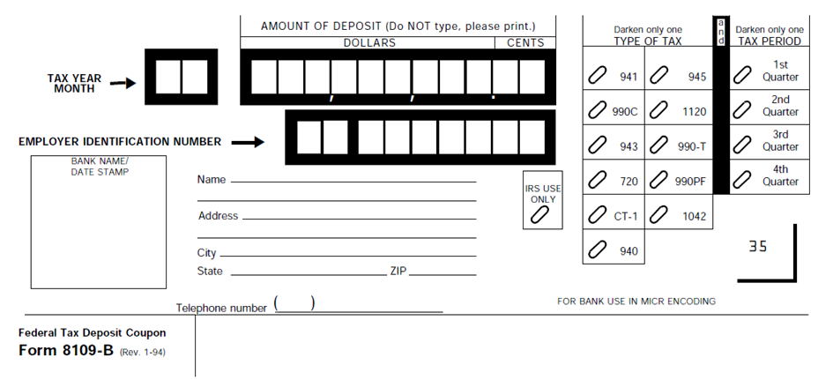
- W-3 (44 points 2 points each 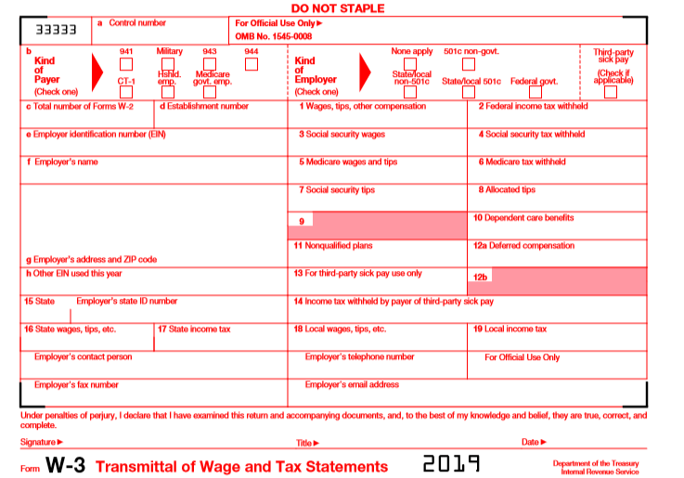

X

4 $278,980 $23,735

12-3456789 $278,240 $17,250.88
USA TOURS COMPANY $278,980 $4,045.21

555 WHITE HOUSE LANE
RICHMOND, VA 98765

VA 12-23456789

$278,980 $11,997

STUDENT NAME (999)123-4567
(999)123-4568 payroll@usatours.com

Student Name ACCOUNTANT current date

4. See 941 on next page - (38 points, 2 points each)
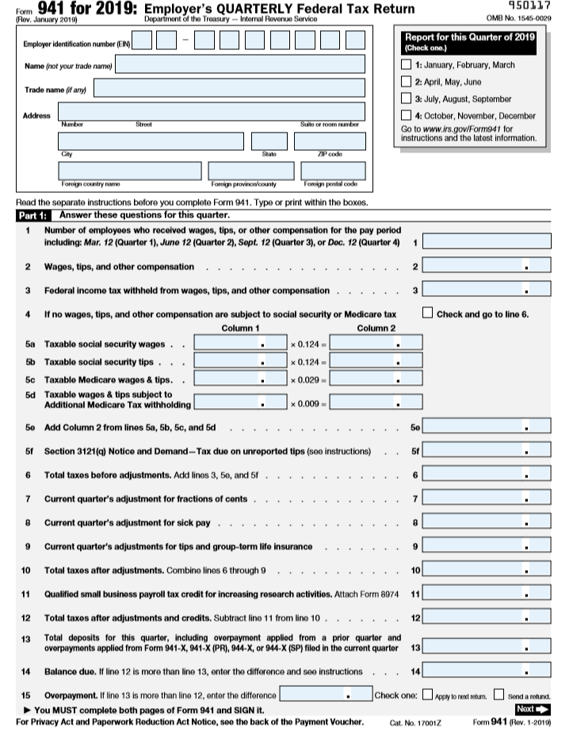

1 2 3 4 5 6 7 8 9

USA TOURS COMPANY X

555 WHITE HOUSE LANE

RICHMOND VA 98765

4
64,380 00
5,931 00

64,380 00 7,983 12

64,380 00 1,867 02

9,850 14

15,781 14

15,781 14

15,781 14

15,781 14

